Argumentative Essay

PROMPT: Modern technology and scientific innovation have helped to make our lives easier. Or have they? Some would argue that the development of modern technology and scientific innovation has actually been a detriment to society. Others could make the argument that technology and scientific innovation has allowed us to become more effective and efficient, thereby making us more productive citizens. Using evidence from multiple textual sources and the texts we have read in class, provide an argument for either side of the issue. You should use your dystopian novels, short stories, non-fiction articles and other unit materials to support your argument. Be sure to refer to specific examples from the texts and your research to support your claim.

FORMAT (5 PARAGRAPHS)

Introduction
Hook: Did you include a creative opening sentence that engages your reader?
Brief summary of the issue
Thesis: Clearly and concisely state your argument
Briefly list 3 supporting reasons: Do not over-tell what you are going to write about
Body Paragraphs
3 distinctly separate reasons
Supporting points and details
Facts from the article and personal experience
Counter argument (must be included as ONE of your body paragraphs)
Conclusion
Summarize three supporting reasons
Restate thesis reword! Do not repeat sentences from the introduction
Closing sentence

RUBRIC

 | 5 (25 pts) | 4 (20 pts) | 3 (15 pts) | 2 (10 points)
Grammar/Spelling | Writing has no spelling or grammar errors. | Writing has few (less than 3) spelling or grammar errors. | Writing has some (4-6) spelling or grammar errors. | Writing has many (7+) spelling or grammar errors.
Organization | Writing is organized in paragraphs that make sense. At least five paragraphs are present including introduction, conclusion, and supporting paragraphs. Each paragraph has a clear topic sentence that is maintained throughout the paragraph. | Writing is organized in paragraphs that usually make sense. At least five paragraphs are present including introduction, conclusion, and supporting paragraphs. Each paragraph has a topic sentence that is present throughout. | Writing is organized in paragraphs that somewhat (3-5 errors) make sense. At least five paragraphs are present including introduction, conclusion, and supporting paragraphs. The topic is sentence is weak or is not maintained throughout the paragraph. | Writing is not organized in paragraphs that make sense (more than 5 errors). Less than five paragraphs are present including introduction, conclusion, and supporting paragraphs. Topic sentence is lacking or is lost within the paragraph.
Argument/Claim | The claim is clearly stated in the introduction. Supporting paragraphs are focused on thesis statement and are clearly connected. | The claim is clearly stated in the introduction. Supporting paragraphs clearly elaborate on the argument but make lack some connection. | The claim is clearly stated in the introduction. Some supporting paragraphs connect to the original argument or connection is weak. | The claim is not clearly stated in the introduction. No supporting paragraphs to elaborate and justify argument made.
Text Evidence | At least two quotes are introduced, clearly present and connected back to support. | At least two quotes are clearly present and connected to support. | One quote is clearly present but may be lacking in connection to argument. | No quotes are clearly present or lack in transition and connection.
Argumentative Essay Organizer
THESIS STATEMENT:
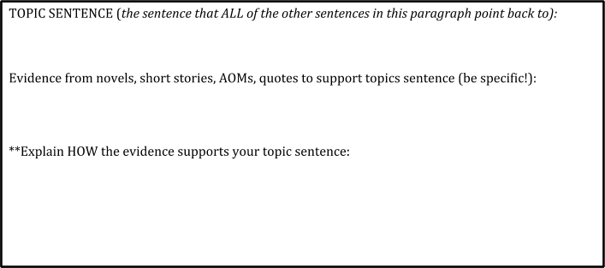
BODY PARAGRAPH #1

COUNTERARGUMENT: Your counterargument can go in any paragraph, as long it is well supported
How will you acknowledge the other side’s opinion and then explain how your reasoning is stronger?

BODY PARAGRAPH #2
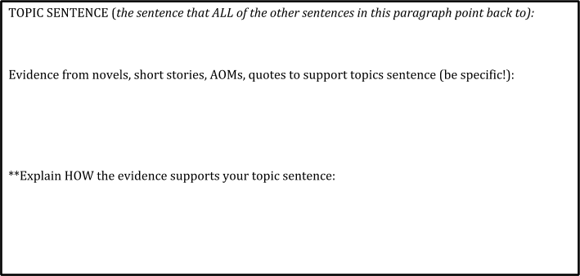

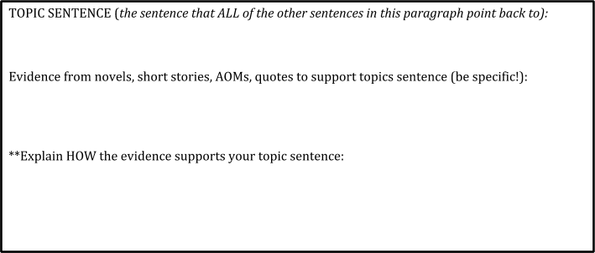
BODY PARAGRAPH #3

Conclusion:
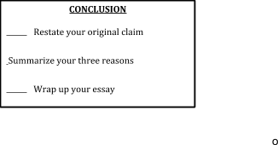

**REMEMBER TO USE FEEDCATS THROUGHOUT YOUR PARAGRAPHS!

Facts, examples, exaggeration, details, causes/effects, anecdotes, testimony/quotes, statistics

