**[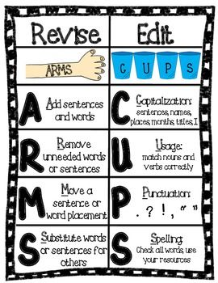](http://www.teacherspayteachers.com/Product/Revising-and-Editing-Chart-ARMS-CUPS-925686)**