Dystopias: Definition and Characteristics

Utopia: A place, state, or condition that is ideally perfect in respect of politics, laws, customs, and conditions.
Dystopia: A , imagined universe in which oppressive societal and the illusion of a perfect society are maintained through corporate, bureaucratic, technological, moral, or totalitarian control. , through an exaggerated worst-case scenario, make a criticism about a current trend, societal norm, or political system.

Characteristics of a Dystopian Society
• is used to control the citizens of society.
• Information, independent thought, and freedom are .
• A figurehead or concept is by the citizens of the society.
• Citizens are perceived to be under constant .
• Citizens have a of the outside world.
• Citizens live in a state.
• The world is banished and distrusted.
• Citizens conform to uniform expectations. and dissent are bad.
• The society is an of a perfect utopian world.

Types of Dystopian Controls
Most dystopian works present a world in which oppressive societal control and the illusion of a perfect society are maintained through one or more of the following types of controls:
• Corporate control: One or more large corporations control society through , and/or .
• Bureaucratic control: Society is controlled by a mindless bureaucracy through a tangle of red tape, relentless regulations, and .
• Technological control: Society is controlled by technology—through computers, robots, and/or . Examples include The Matrix, The Terminator, and I, Robot.
• Philosophical/religious control: Society is controlled by philosophical or religious ideology often enforced through a dictatorship or theocratic government.

The Dystopian
• often feels trapped and is struggling to .
• the existing social and political systems.
• believes or feels that something is with the society in which he or she lives.
• helps the recognizes the negative aspects of the dystopian world through his or her perspective.

Words you might need:
bureaucracy: | A large group of people who are involved in running a government but who are not elected and/or A system of government or business that has many complicated rules and ways of doing things
oppression | unjust or cruel exercise of authority or power
norms: | standards of proper or acceptable behavior
dissent | To publicly disagree with an official opinion, decision, or set of beliefs
Aspect | The way a person, place, or thing appears
banish | To force (someone) to leave a country as punishment
scenario | A description of what could possibly happen
propaganda | Ideas or statements that are often false or exaggerated and that are spread in order to help a cause, a political leader, a government, etc.
theocracy | a form of government in which a country is ruled by religious leaders and/or a country that is ruled by religious leaders
dictatorship | Rule, control, or leadership by one person with total power and/or a government or country in which total power is held by a dictator or a small group
philosophy | a set of ideas about how to do something or how to live
2 column notes

Utopia: A place, state, or condition that is ideally perfect in respect of politics, laws, customs, and conditions.

Dystopia: A futuristic, imagined universe in which oppressive societal control and the illusion of a perfect society are maintained through corporate, bureaucratic, technological, moral, or totalitarian control. Dystopias, through an exaggerated worst-case scenario, make a criticism about a current trend, societal norm, or political system.

What is it?
Definition:

_____________
Word

Examples Non-Examples

Illustration

Characteristics of a Dystopian Society
• Propaganda is used to control the citizens of society.
• Information, independent thought, and freedom are restricted.
• A figurehead or concept is worshipped by the citizens of the society.
• Citizens are perceived to be under constant surveillance.
• Citizens have a fear of the outside world.
• Citizens live in a dehumanized state.
• The natural world is banished and distrusted.
• Citizens conform to uniform expectations. Individuality and dissent are bad.
• The society is an illusion of a perfect utopian world.

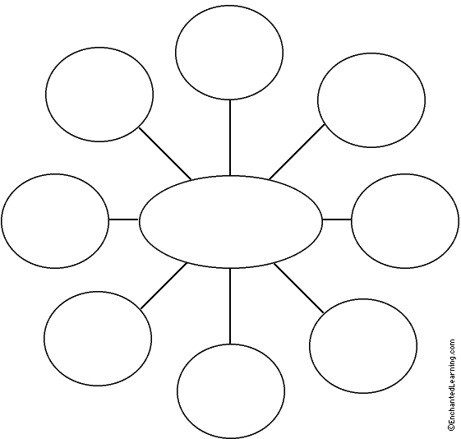

Cluster

Types of Dystopian Controls
Most dystopian works present a world in which oppressive societal control and the illusion of a perfect society are maintained through one or more of the following types of controls:
• Corporate control: One or more large corporations control society through products, advertising, and/or the media. Examples include Minority Report and Running Man.
• Bureaucratic control: Society is controlled by a mindless bureaucracy through a tangle of red tape, relentless regulations, and incompetent government officials. Examples in film include Brazil.
• Technological control: Society is controlled by technology—through computers, robots, and/or scientific means. Examples include The Matrix, The Terminator, and I, Robot.
• Philosophical/religious control: Society is controlled by philosophical or religious ideology often enforced through a dictatorship or theocratic government.
Topic/Main Idea

Hierarchical chart

The Dystopian Protagonist
- often feels trapped and is struggling to escape.
- questions the existing social and political systems.
- believes or feels that something is terribly wrong with the society in which he or she lives.
- helps the audience recognizes the negative aspects of the dystopian world through his or her perspective.

Supporting details

Main Idea

Supporting details

Herringbone

