What I Treasure Most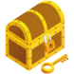
Brainstorming a Personal Narrative
What do you treasure most in the world? Think beyond just objects. People, animals, special skills or qualities you possess can all be considered treasures.
When I think about what I treasure, what stands out is…
____________________ ____________________ ________________________ ____________________
____________________ ____________________ ________________________ ____________________

Choose something from your list that has an interesting story behind it. It could be something you lost and then found again, something you gained through hard work, or something that was a surprise. Or you might relate a story about a person or animal that is special to you. Remember that the purpose of the piece is to share something about yourself in the process.
Pick one treasure from your list and describe it. ________________________________________________________________________________________________________________________________________________________________________________________________________________________________________________________________________________________________________________________________________________________________________________________________________

What sensory details can you include to help make your narrative more interesting?
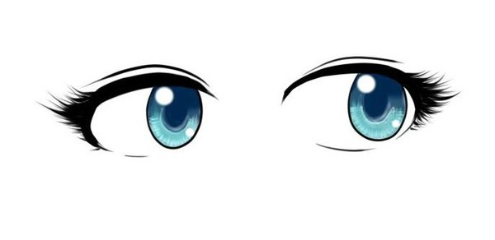______________________________________________________________________________________________________
______________________________________________________________________________________________________
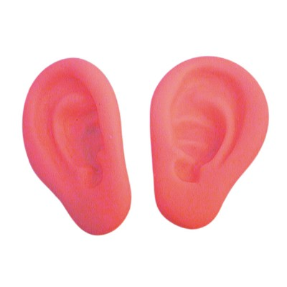____________________________________________________________________________________________________
_____________________________________________________________________________________________________
______________________________________________________________________________________________________
.
Briefly outline the events you would like to include in your narrative.
First,_______________________________
___________________________________
Next, ___________________________________
___________________________________
Then, ___________________________________
___________________________________
Finally, ___________________________________
___________________________________

Set the Scene: Provide Information the reader will need to understand your story.
When /Where does the story take place?
______________________________________________________________________________________________________________________________
__________________________________________
Who is in the story with you? ____________________________________________________________________________________________________________________________________________________________________________________________

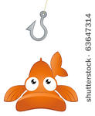The Hook: Catch your reader’s attention with your first sentence
___________________________________________________________________________________________________________________________________________________________________________________________________________________________________________________________________________
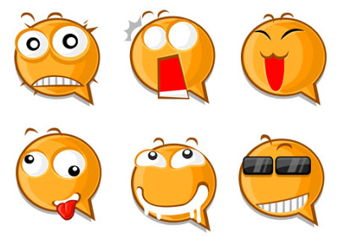Emotions, Feelings and reactions you want to share with the reader:
________________________________________________________________________________________________________________________________________________________________________________________________________________________________________________________________________________________________________________________________________________________________________________________________

